Math 110, Spring 2007, Practice Final Exam WITH ANSWERS
Instructions
- Closed book, closed notes, except for one 8.5”-by-11” (or A4) sheet of paper, okay to use both sides. You may be required to turn in your note sheet with the exam, so write your name on it.
- 90 minutes are allowed for this exam.
- Clearly indicate your answer.
- You must show all relevant work and justify your answers appropriately.
- Partial credit will be given, but not without sufficient support.
- No calculators that have a QWERTY-type keyboard are allowed. The proctor's discretion is final.
- When appropriate, you must use the words "nominal" or "real" or “effective”, or “APR” or “APY”
- When appropriate, you must properly use the word “point” as in “percentage point.”
- THIS PRACTICE TEST DOES NOT INCLUDE EVERY TOPIC THAT MIGHT BE ON THE REAL TEST!
- A good way to study is to make a list of all the types of problems we’ve talked about (in class, worksheets, the textbook, homeworks, and projects) and make sure you know how to do each type, and understand the connections between them.
Name: _______________KEY________________________
I have worked on this exam in a completely honest fashion. I have neither given nor received help.
Signature:______________________________________________
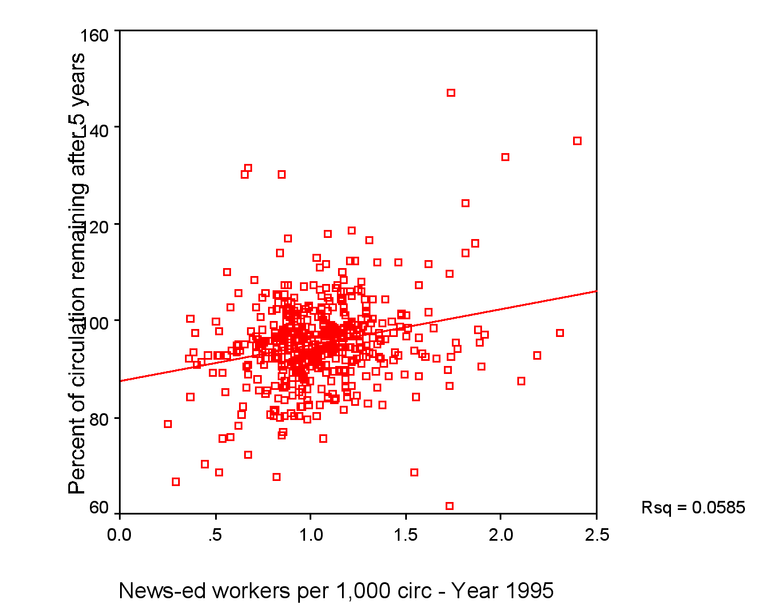
#1[20 pts] The article “How Many News People Does a Newspaper Need?” by Philip Meyer and Minjeong Kim shows the following scatterplot. The horizontal axis is a measurement of how many staffers the newspaper has. The vertical axis talks about how much the newspaper’s circulation has changed in 5 years; higher values are better. The vertical scale is from 60 to 160 (I mention this because some of the digits got cut off by the axis label)

- Estimate by eye the percent of circulation remaining after 5 years at the value x=0.5; use an appropriate amount of precision: anything between 85 and 95 is okay
- The article says “the slope is 7.427, starting from a y intercept of 87.4”. Write an equation relating x and y.
y = 7.427 x + 87.4
- Compute the percent of circulation remaining after 5 years at the value x=0.5; give at least one decimal digit of precision.
y= 7.427 * 0.5 + 87.4 = 91.1135
- How much confidence do you have in this prediction? Give both a qualitative and quantitative answer.

I have very little confidence in the prediction. The data doesn’t look very linear, and the R-squared value is very low (0.0585, in the lower-right corner of the figure); this is a very weak correlation.
- Does this graph mean that newspapers should increase their staffing? Explain why or why not in a sentence.
It does not mean that newspapers should increase their staffing; for one thing, correlation does not imply causation, so even if there was a strong correlation, it wouldn’t guarantee better circulation for increasing your staffing. But in this case, there isn’t even a good correlation!

#2[4 pts]What is the Gambler’s Fallacy?

If something hasn’t happened as often as you expected, it is more likely to happen in the near future.

#3[8 pts] A study says: “Roberson and colleagues sent a brief, anonymous survey to 2,500 members of the American Academy of Otolaryngology-Head and Neck Surgery, and received 466 responses.Of these, 210 physicians reported that a medical error had occurred in their practice in the past six months.”
a) What sorts of problems might such a study methodology have?
Self-section bias is the biggest problem. A physician that had a lot of recent errors would be less likely to return the survey. A busy physician would also be less likely to return it; perhaps busy physicians are also mistake-prone as well. The embarrassment associated with admitting errors is another source of bias. Also, they are only sampling otolaryngologists; this doesn’t tell us much about other medical specialties.

b) According to this study, what is the probability of a practice making a medical error in the last six months? Give it as a fraction and as a percent.
It’s 210/466, or 45.06%.

#4[8 pts] ] a) Draw a graph that displays economies of scale, i.e. the cost per item decreases as the number of items purchased gets larger.

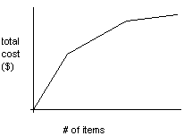

b) In such a case, should you order a whole bunch at once and then nothing, or should you try to spread your purchases out over several weeks?

You should order a whole bunch at once and then nothing.

c) Describe a time when you personally have taken advantage of economies of scale.

Any time you’ve bought a case of soda instead of many six-packs, or a six-pack instead of six single cans/bottles at a vending machine.
If you’ve bought a pitcher instead of many pints at a bar, or a keg instead of many cases, that’s economies of scale.

#5[12 pts] The CPI in 2000 was 172.2 and in 2006 it was 201.6.
a) What was the average yearly rate of inflation from 2000 to 2006?

2.662%

b) Suppose the cost of a meal at McDonald’s was $3.40 in 2000, and in 2006 it was $4.30. Write two true quantitative sentences (both using percents) that describe how the cost of a meal changed.

The nominal cost of a meal at McDonalds increased 26.47% from 2000 to 2006.
The real cost of a meal at McDonalds increased 8.027% from 2000 to 2006.

#6[12 pts] a) Define accuracy.

Accuracy is the degree to which your answer comes close to the true answer.

b) Define precision.
.
Precision is the number of digits (other than trailing zeros) that are given in an answer.

c) Is it better to be accurate but not precise, or precise but not accurate? Write at least a sentence in response.

It’s better to be accurate but not precise. For example, if your speedometer is accurate but not precise, it might tell you you’re going
60 mph when you’re actually going 62; as long as you’re in a 60 zone, you’re probably okay. But if it’s precise but not accurate,
it might tell you you’re going 55.423 mph when you’re actually going 62mph, thus tempting you to speed up.

#7 [6 pts] Suppose the percent of patients without insurance at a hospital went from 25% in 2005 to 30% in 2006.
a) what percentage increase is this?

It is an increase of 20 percent.

b) what percentage point increase is this?

It is an increase of 5 percentage points.

#8[12 pts]A particularly quantitative doctor gives a patient the following distribution on his remaining lifetime:
# of years | 1 | 2 | 3 | 4
probability | .15 | .50 | .10 | .25
- What is the probability that the patient will live 2 or more years?

0.85 or 85%
- What is the expected length of the patient’s remaining life?
It is 2.45 years.

- If 200 similar patients were tracked, how many of them would you expect to live only one year?
I would expect about 30 of them to live only one year.

